### **Introduction**

The **Assignment Problem** is a special type of **Linear Programming Problem (LPP)** that deals with **assigning tasks or jobs to agents or machines** in such a way that the **total cost or time is minimized** (or profit is maximized), subject to the condition that each task is assigned to exactly one agent and vice versa.

It is widely applied in:

* Job scheduling
* Task allocation
* Resource assignment
* Staff rostering
* Machine loading

### **Characteristics of the Assignment Problem**

* Number of tasks = number of agents
* Each agent is assigned to exactly one task
* Each task is assigned to exactly one agent
* The objective is to **minimize cost or maximize profit**

## **Mathematical Formulation of the Assignment Model**

Let:

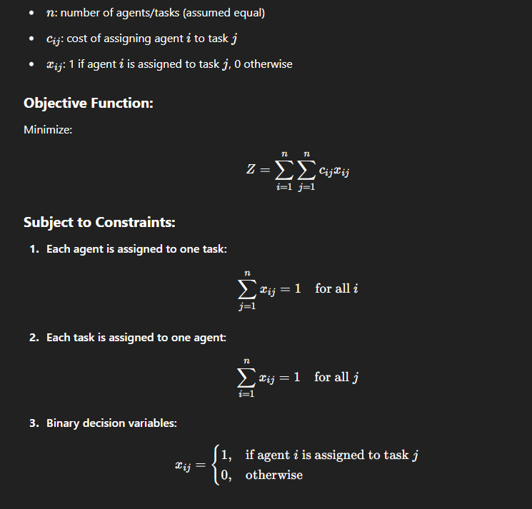

## **Solution of Assignment Problem**

The **Hungarian Method** is the most widely used method to solve the assignment problem efficiently in polynomial time.

### **Steps in the Hungarian Method:**

1. **Construct the cost matrix.**
   * If it's a maximization problem, convert it to a minimization problem (e.g., by subtracting each value from the maximum element).
2. **Row Reduction:**
   * Subtract the smallest value in each row from every element in that row.
3. **Column Reduction:**
   * Subtract the smallest value in each column from every element in that column.
4. **Cover all zeros using a minimum number of lines.**
   * Use horizontal or vertical lines.
5. **Check:**
   * If the number of lines = nnn, an optimal assignment is possible among zeros.
6. **If not optimal:**
   * Find the smallest uncovered value, subtract it from all uncovered elements, and add it to elements at intersections of lines.
   * Repeat the covering process until the optimal number of assignments is possible.
7. **Make assignments:**
   * Choose zero elements in such a way that no row or column has more than one assignment.